March 17, 2023 – Java Project – Thea Gregory 5291240

Today I worked on the following:

* Began the MVC logic for the New Client View
* Made the model and all validation methods
* Created the controller
* Successfully connected to the database to verify that the username was free
* Troubleshot linking the New Client frame to the Login Frame with success.

I spent a good deal of my time doing research, when it came to figuring out why the actionlisteners in my view weren’t working. It turned out I hadn’t realized I needed to call the model and view with it. After that, the validate username function worked with no issues. I can use this knowledge to accelerate work on the rest of the project, because much of the project is self-similar. I am happy with my progress, because it will avoid future timesinks. Using mysql with Java is much easier than I thought so that part is going well. Code screenshots to follow.

Screenshots:

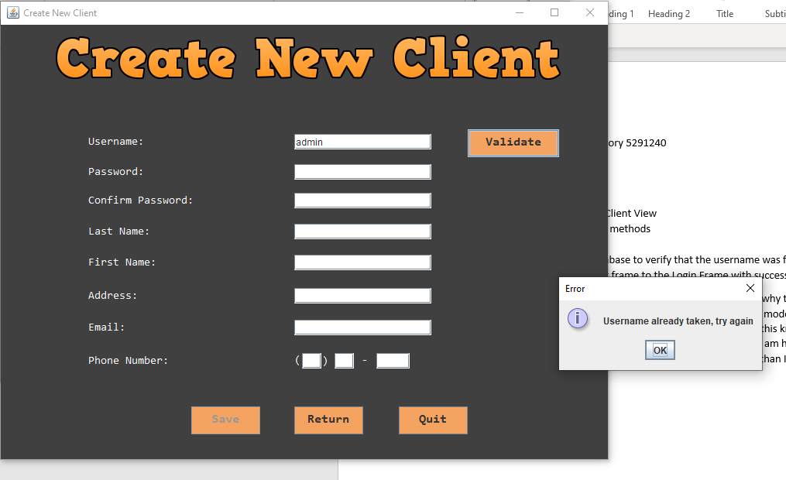

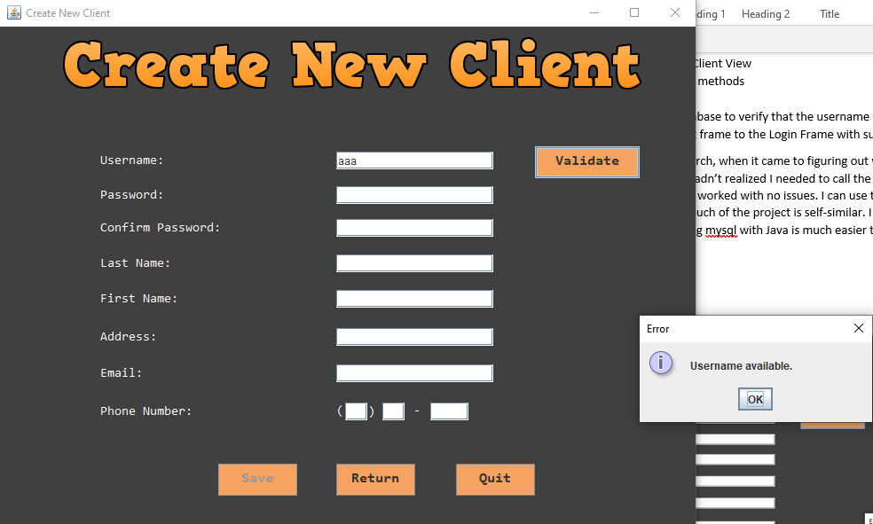

Some validation methods:

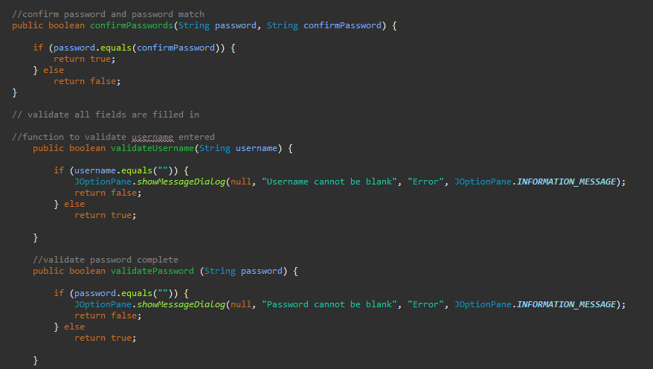

The start of the actionlistener for the Create New Client buttons:

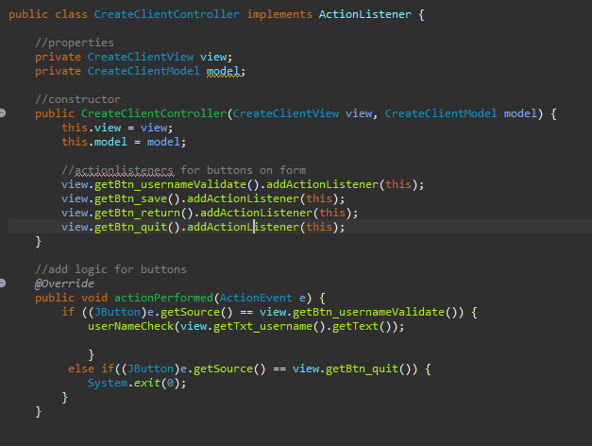

The check username DB function:

